**Clothing Database Management System**

Shaik Masthan Vali

<https://github.com/Masthan9712/True-Style-Clothing.git>

April 5, 2022

I have created a business for selling textiles known as “True Style Clothing”.

For this business I will be creating a new database which stores all the information regarding Employees (Employee ID, Names, Job role & Salary), Customers (Customer Name, Date of Birth, Phone, Email & Address), Transactions (Transaction amount & transaction method), Costume (Costume ID, Brand, Quantity, Price & Size) and Categories (Men, Women, Kids). This data is very essential for running the store to keep track of all the orders, employees and their salary pay, offering discounts to the regular customers and maintain the stock up to date. If the stock is less, more collection needs to be ordered. Everyday transactions gives the overview of the most salable and liked costumes which helps to order those costumes more in quantity.

I have to enter the employee data at the time of their joining and it contains all details about their role and pay. Customer data is generated when they purchase any costume from the store.

As I am running this store, I should be able to view all the data to get a detailed overview of how the business is running and what needs to be taken care of. Store managers needs access to all the employee data and the costumes data. In case if any particular costume is running low in that store they can check whether it is available in the near store. Sales team needs to have access to the transactions data to check how well the costumes are getting sold. If the business is running good, sales team can make analysis to put some offers on the most salable costumes and even encourage customers to buy it.

**Week 2 - Project part 2**

For my True Style Clothing business application I will be creating 6 entities and described them below:

1. Customer Info - This entity describes the basic information of a customer like Customer First Name, Customer Last Name, Customer Email, Customer DOB, Customer Orders.
2. Employee Info - This entity describes the employee information like Employee ID, Employee First Name, Employee Last Name, Employee Role, Employee Salary, Employee Sales.
3. Costume Info - This entity describes the Costume ID, Brand, Shirts Price, Trousers Price.
4. Category info - This describes the available sizes for all categories. S - small, M - Medium and L - Large, Gender - Male and Female and Age.
5. Vendor Info - This entity describes the Vendor name, Delivery Date, Shirts Quantity, Trousers Quantity.
6. Sales Info - This entity describes the sales details like Date, Number of costumes sold, Total sale value.

Below is the chart representation for my entities:

|  |  |
| --- | --- |
| **Customer Info** | **Data type** |
| Customer First Name | varChar[30] |
| Customer Last Name | varChar[30] |
| Customer Email | varChar[30] |
| Customer DOB | date |
| Customer Orders | Integer |

|  |  |
| --- | --- |
| **Employee Info** | **Data type** |
| Employee First Name | varChar[30] |
| Employee Last Name | varChar[30] |
| Role | varChar[30] |
| Salary | Float |
| Sales Completed | Integer |

|  |  |
| --- | --- |
| **Costume Info** | **Data type** |
| Costume ID | Integer |
| Brand | varChar[20] |
| Shirts price | Float |
| Trousers price | Float |

|  |  |
| --- | --- |
| **Categories Info** | **Data type** |
| Gender | char |
| Size | char |
| Age | int |

|  |  |
| --- | --- |
| **Vendor Info** | **Data type** |
| Vendor Name | varChar[20] |
| Delivery date | date |
| Shirts Quantity | Integer |
| Trousers Quantity | Integer |

|  |  |
| --- | --- |
| **Sales Info** | **Data type** |
| Date | date |
| Costumes Sold | Integer |
| Sale value | Float |

**Week 3 - Project Part 3**

**UML diagram - UMLet**

I have used the UMLet tool for drawing the UML diagram for my business application TrueStyleClothing.

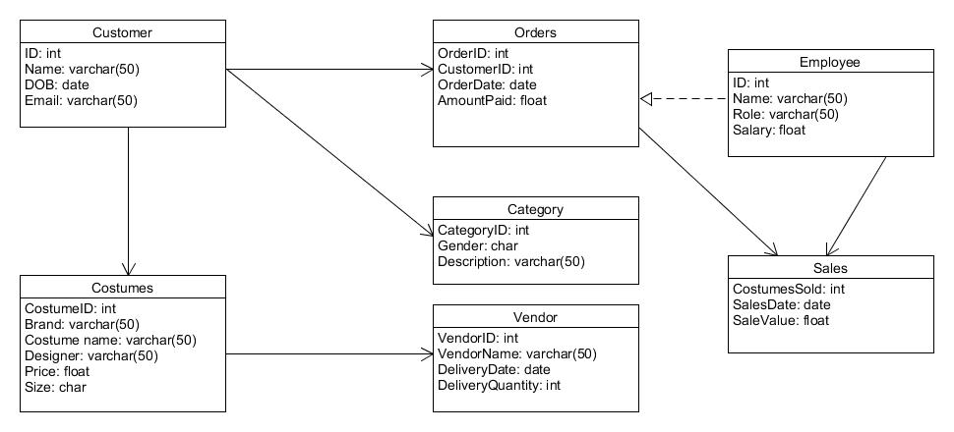

**ER Diagram - Crow’s Foot Model:**

